Dear [First Name],
We are pleased to welcome you to the PEOPLElogy 25th Anniversary at Renaissance Hotel Kuala Lumpur.
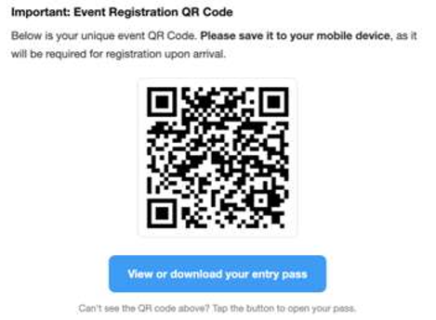
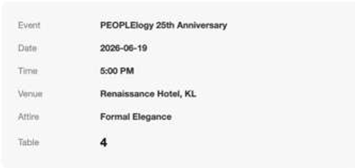

Dietary Requirements
To help us better accommodate our guests, if you require a vegetarian meal, kindly reply to this email by Friday, 12 June 2026.
We are excited to celebrate this milestone with you and look forward to creating memorable moments together.

Warm regards,
PEOPLElogy Berhad

